***Amazon Pantry***

***Project Task: 1 (This is on the Business Analysis concepts taught)***

***Identifying Stakeholders –*** Customer, Employee’s, Management, Delivery boy,

***Main features that need to be developed –***

1. New feature called *ABC Pantry*, on clicking this feature, it would open up a new range and categories of products.
2. There should be a logical grouping of products for customers to search for daily essential items they wish to buy. The following categories should be included:

* Flour and rice
* Sugar, salt, and spices
* Pulses
* Personal care
* Snacks
* Hand wash and sanitizers
* Household cleaning essentials
* Breakfast food items
* Tea and coffee
* Baby care
* Female hygiene
* Tissues and fresheners

1. Show five advertisements.
2. Show certain offers that are created for customers.
3. Shopping cart.

***Write the in-scope and out-of-scope items for this software.***

***In-scope – Out-scope***

|  |  |
| --- | --- |
| * Non-essential products and essential product * Advertise for the revenue of company. * Cart for the save or for favourite item. * Order more than 30 USD. * Free Delivery will be offered only if the total order exceeds 50 USD. | * Only one is not available. * Total order less than 30 USD can’t accept. * Free Delivery will not be offered less than 50 USD. |

***Business requirements: –***

***Functional requirements –***

1. New feature called *ABC Pantry*, on clicking this feature, it would open up a new range and categories of products.
2. There should be a logical grouping of products for customers to search for daily essential items they wish to buy. The following categories should be included:

* Flour and rice
* Sugar, salt, and spices
* Pulses
* Personal care
* Snacks
* Hand wash and sanitizers
* Household cleaning essentials
* Breakfast food items
* Tea and coffee
* Baby care
* Female hygiene
* Tissues and fresheners

1. Show certain offers that are created for customers.
2. Shopping cart.
3. Free Delivery will be offered only if the total order exceeds 50 USD.
4. Show certain offers that are created for customers.

***Nonfunctional requirements –***

* Advertisement
* Software for new feature

**Project Task: 2 (This is on the agile scrum concepts taught)**

***User story 1 -***

**As a** order manager, **I want** ability to update and change the list **so that** the customer is able to get the list of product

Acceptance criteria –

* Register
* Enter detail
* OTP
* Employee id

***User story 2 –***

**As a** Manager, **I want** ability to check the order **so that** maintain the quantity of item.

Acceptance criteria –

* Stock
* Item code
* Category
* Employee id

***User story 3 -***

**As a** customer, **I want** ability to login and order **so that** i get the place order of product.

Acceptance criteria –

* Login
* Enter detail
* OTP
* Payment mode
* Conformation otp

***User story 4 -***

**As a** Delivery boy, **I want** to deliver the product or order **so that** I need the order details and order id

Acceptance criteria –

* Order id
* Address pin code
* Customer detail
* Payment mode detail

**Project Task: 3 (This is on the Tableau concepts taught)**

1. Create a dashboard for senior management for Chicago to view sales of personal care products for the last 6 months & for Chicago to view sales of breakfast products for the last six months.

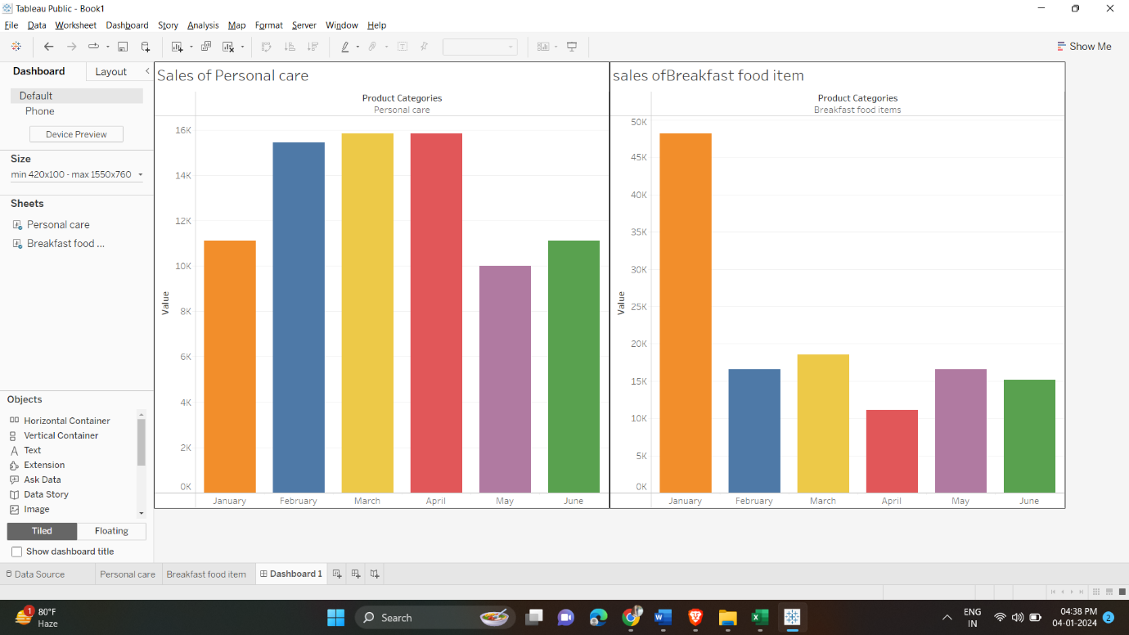

**Project Task: 4 Excel**

***Attached the file***